**树莓派/闲置电脑+硬盘、阿里云服务器、Nginx+python/php编程语言+MySQL搭建网站、frp内网穿透**

1. [网云穿](https://blog.csdn.net/jinli10/article/details/110184573)

安装Nginx

sudo apt-get install nginx

# ~下 使用 wget 命令下载网云穿客户端

wget http://xiaomy.net/download/linux/wyc_linux_arm

# 设置可执行权限

sudo chmod a+rwx wyc_linux_arm

网云穿注册登录领取免费隧道

Web:ip=127.0.0.1,port=80(Nginx端口),协议为https

SSH:ip=127.0.0.1,port=22(SSH端口),协议为TCP

|  |  |  |  |  |  |
| --- | --- | --- | --- | --- | --- |
| 用户名 | 密码 | 令牌 | 域名 | 端口 | 用途 |
| 18931983446 | L1659823781. | p6atnj43 | u72nm2ds.dongtaiyuming.net | 80 | Nginx |
| 15226648017 | L1659823781. | gv52ik50 | 0s27xt24.dongtaiyuming.net:21848 | 22/5901 | SSH/VNC |
| 15226729850 | L1659823781. | 5mep3p8o | b8mta78p.dongtaiyuming.net | 8081 | Camear |

# 启动网云穿客户端

# 其中 XXXX 是你刚才获取到的“令牌”

./wyc_linux_arm -token p6atnj43

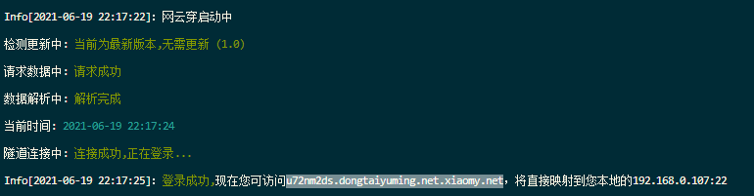

<http://u72nm2ds.dongtaiyuming.net/>

2. [frp内网穿透+mjpg_streamer](https://zhuanlan.zhihu.com/p/128590336)